EcoCast Database Schema Documentation
Project Overview
EcoCast is an automated ETL pipeline that extracts weather forecast data from the Open-Meteo API, transforms the JSON response into structured tabular data, and stores it in PostgreSQL for renewable energy analytics and dashboard visualization.
The database is designed using a relational schema with primary and foreign key relationships to support scalable querying and analytics workflows.

Table 1: Locations
 | Data type | Key | Description
Location_id | Serial | Primary key | Unique identifier for each location
City_name | Varchar(100) |  | Name of the city
Latitude | Decimal(8,5) |  | Geographic latitude
Longitude | Decimal(8,5) |  | Geographic longitude
timezone | Varchar(100) |  | Timezone of the location

Table 2: weather_forecasts
 | Data Type | Key | Description
forecast_id | SERIAL | Primary key | Unique forecast record identifier
location_id | INTEGER | Foreign key | References locations.location_id
forecast_time | TIMESTAMP |  | Forecast date and time
temperature | DECIMAL(5,2) |  | Temperature in Celsius
cloud_cover | INTEGER |  | Percentage cloud coverage
wind_speed | DECIMAL(5,2) |  | Wind speed in km/h
wind_direction | INTEGER |  | Wind direction in degrees
Table 3: renewable_scores
 | Data Type | Key | Description
score_id | SERIAL | Primary Key | Unique renewable score identifier
forecast_id | INTEGER | Foreign Key | References weather_forecasts.forecast_id
solar_score | DECIMAL(5,2) |  | Estimated solar generation potential
wind_score | DECIMAL(5,2) |  | Estimated wind generation potential
recommendation | VARCHAR(100) |  | Suggested renewable energy condition

Database Relationships
- The EcoCast database follows a relational structure that connects locations, weather forecasts, and renewable energy analytics.
- Each location may contain multiple weather forecast records.
- Each weather forecast record may contain one renewable energy scoring record.
- Foreign key constraints are used to maintain referential integrity across all related tables.

Relationship Structure:
locations (1) ---- (Many) weather_forecasts
weather_forecasts (1) ---- (1) renewable_scores

ERD
Figure 1. Entity Relationship Diagram (ERD) illustrating the relational structure of the EcoCast PostgreSQL database schema.
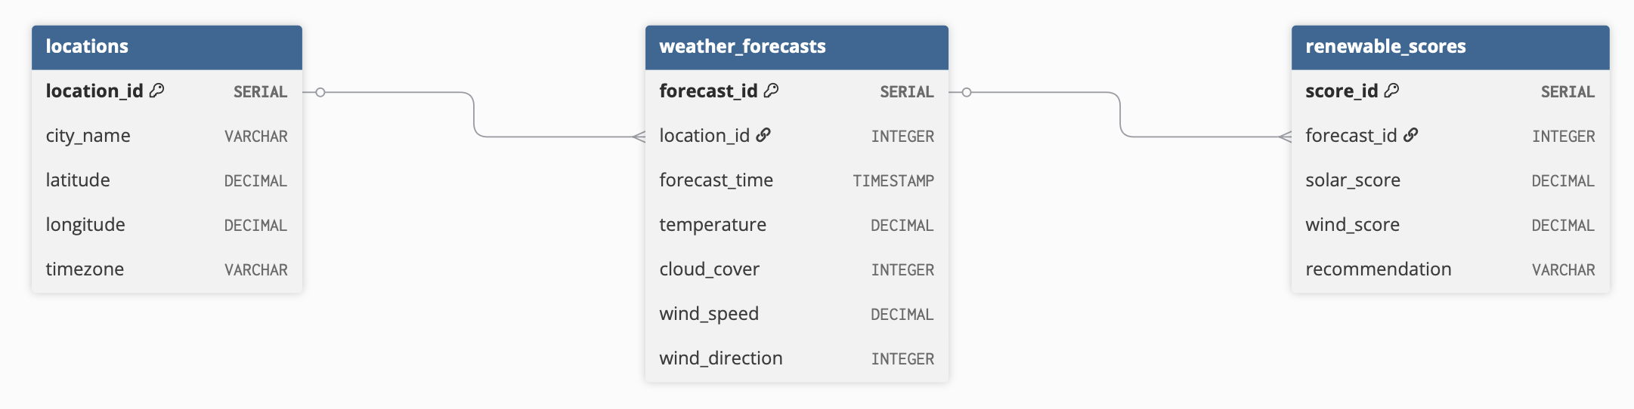

Initial PostgreSQL Load Script

CREATE TABLE locations (
location_id SERIAL PRIMARY KEY,
city_name VARCHAR(100) NOT NULL,
latitude DECIMAL(8,5),
longitude DECIMAL(8,5),
timezone VARCHAR(100)
);

CREATE TABLE weather_forecasts (
forecast_id SERIAL PRIMARY KEY,
location_id INTEGER NOT NULL,
forecast_time TIMESTAMP NOT NULL,
temperature DECIMAL(5,2),
cloud_cover INTEGER,
wind_speed DECIMAL(5,2),
wind_direction INTEGER,
CONSTRAINT fk_location
FOREIGN KEY (location_id)
REFERENCES locations(location_id)
);

CREATE TABLE renewable_scores (
score_id SERIAL PRIMARY KEY,
forecast_id INTEGER NOT NULL,
solar_score DECIMAL(5,2),
wind_score DECIMAL(5,2),
recommendation VARCHAR(100),
CONSTRAINT fk_forecast
FOREIGN KEY (forecast_id)
REFERENCES weather_forecasts(forecast_id)
);

The PostgreSQL schema creation script was successfully executed in the SQL editor environment without errors. All tables, primary keys, and foreign key relationships were successfully created.
Figure 2. Successful execution of the PostgreSQL schema creation script.
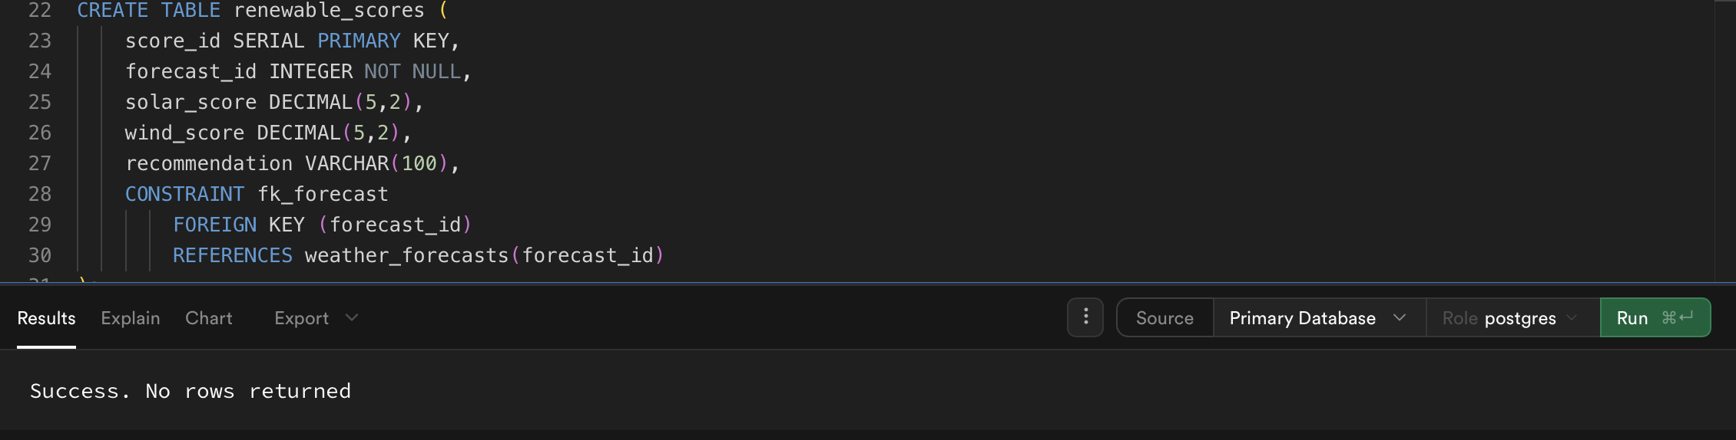

The schema is designed to support future ETL automation, analytical querying, and renewable energy dashboard reporting.

